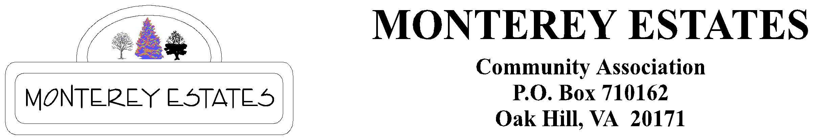
MECAHOA.ORG

Sellers Request for Disclosure Packet

Preparation for Sale of lot in Monterey Estates Community Association

TO: MECA Board
RE: Request for Disclosure Packet
DATE: _________________________________

FROM: _________________________________

Address: _________________________________

Telephone: _________________________________

EMAIL: _________________________________

Email THIS completed application to ALL the following contacts. Please note that the turnaround time for a disclosure packet is up to 2 weeks.
- Disclosure packet coordinator Cameron Eckhardt mecahoasocial@gmail.com
- ACC Chair Members: Dino Garcia MECA.ACC.VA@gmail.com
- Treasurer: Lang Nguyen lang_nguyen8574@yahoo.com
- The ACC chair will inspect your lot for clearance.
- The Treasurer will confirm current payment of dues for clearance.
- The Disclosure packet coordinator will complete the disclosure packet and notify you when it is ready.
- The cost of a disclosure packet is $100.00. It must be paid at time of packet delivery. Payment can be made through our website or by check. Virginia law effective July 1, 2010, allows self-managed homeowner associations (i.e., managed by residents) to require payment for a resale disclosure packet at the time the packet is delivered. See http://leg1.state.va.us/cgi-bin/legp504.exe?101+sum+hb702

